The EMHEATER PC Software allows for the connection of a PC with EMHEATER VSDs using a USB to RS485 Dongle.

Wiring:
- Make sure that the jack on the EMHEATER VSD Control Board is inserted/connected to allow RS485 Communication (this is the default).
- Connect the 485+ Terminal to the + Terminal of the USB Dongle.
- Connect the 485- Terminal to the - Terminal of the USB Dongle.
- Switch the power supply to the VSD on and insert the USB Dongle into the PC/Laptop USB Port.

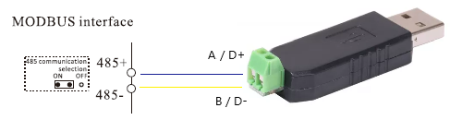

Check USB Port:
- To confirm the PC/Laptop USB Port being used for the connection, open the PC/Laptop Control Panel>Device Manager and identify the COM Port used as illustrated below (COM5 in the below example):
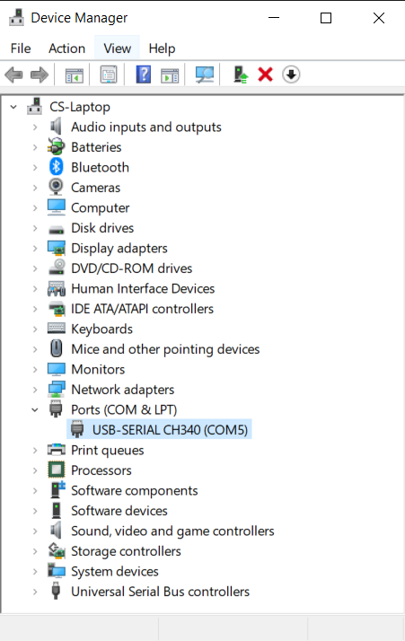

Software Setup:
- Locate the .rar file which contains the PC Software and Double Click on the file.
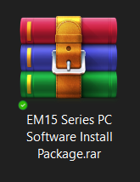
- Select the UpPCMonit.exe file and Double Click on it to run the Software.
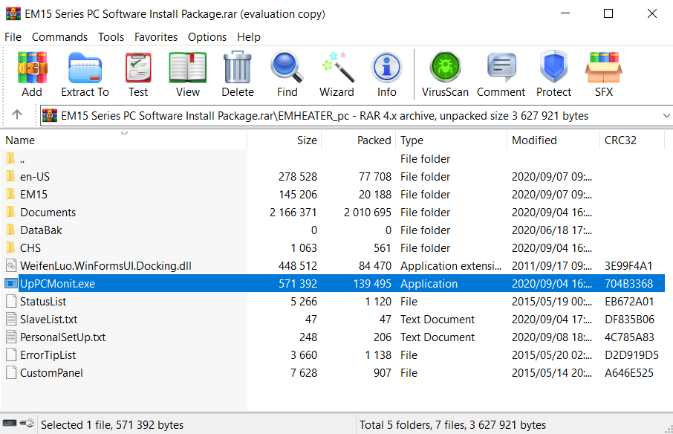
- The UpPCMonitor programme will open as follows:
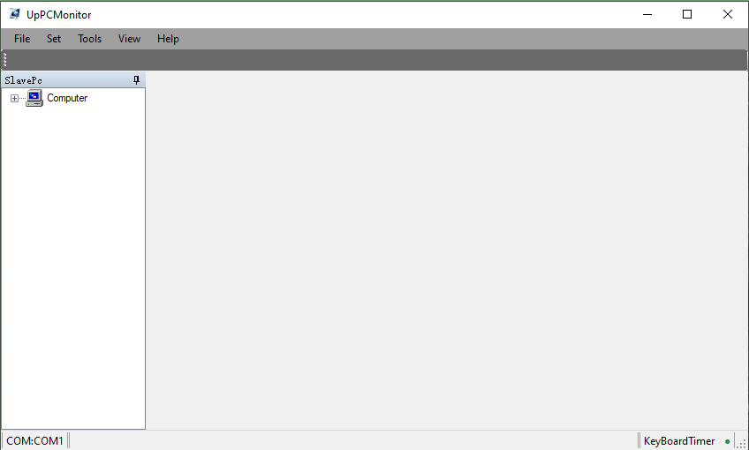

- Select the “Set>Select COM” menu option.
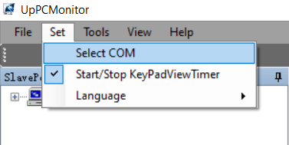
- A new pop window will open. Select the “Search” button which will refresh all the options in the “COM” dropdown list.
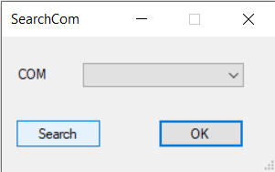
- Select the COM port identified as the port being used for the USB Dongle (as identified during an earlier step) and then select “OK”.
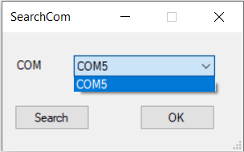
- Right click on the “Computer” button and select “Add”.
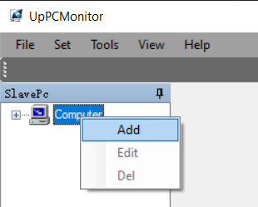

- A new pop-up window will appear. In the “Message” box, type a friendly name to be used to identify the specific VSD connection you will be using. Also ensure you select the correct “Series” and “Power” option for the specific VSD. Leave the other 3 settings as is and select “OK”.
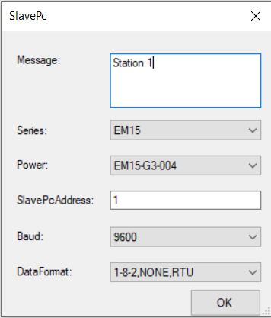
- Expand the “Computer” directory which will then show an option with the same name as provided in the “Message” box in the previous step. Double click on this item, which will open up a pop-up screen, and select “Yes”.
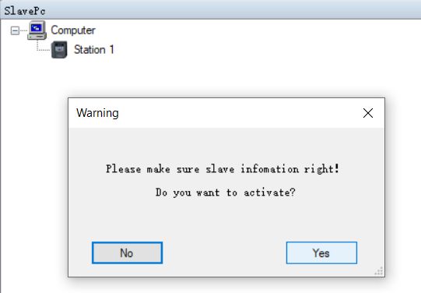
- After this the UpPCSoftware will display as follows:
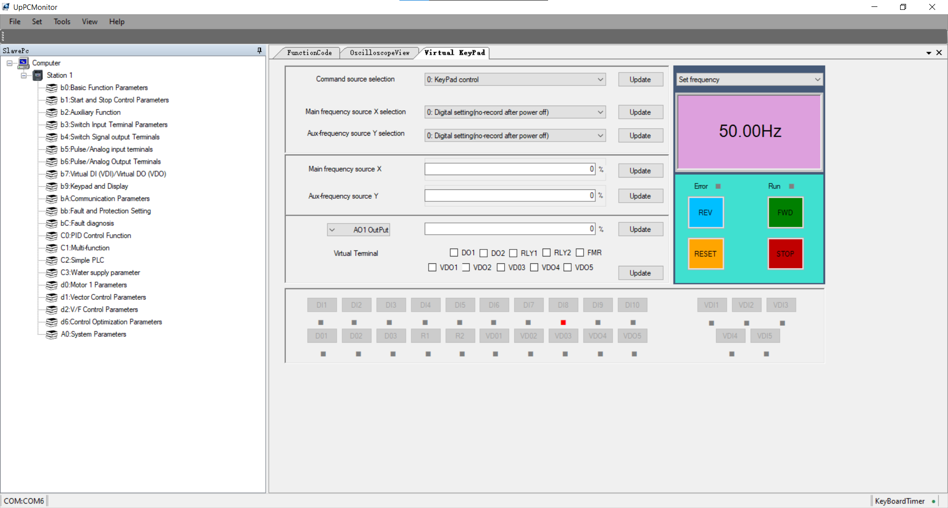
- On the left panel the various Parameter Groups will displayed with 3 tabs (FunctionCode, OscilloscopeView and Virtual Keypad), each with its own view, being displayed on the right.
- FunctionCode Tab: The various groups of parameters shown on the left panel are used to change the list of parameters being shown on the “FunctionCode” tab on the right. By Double Clicking on a parameter group on the left panel, the list of parameters on the right will be updated and can be used to read and update the actual values as set on the VSD. To change a parameter, click on a parameter from the list displayed on the right – by selecting the “Read” function at the bottom the software will retrieve the value of the specific parameter as set on the VSD. To change the value, select the “ChangeData” function at the bottom, which will open a pop-up screen to allow for entering a new desired value – click “OK” after entering the value. After doing this, select the “Write” function at the bottom which will then update all changed parameter values on the VSD (multiple values can be changed before writing the changes to the VSD). To export the parameter values, select the “File>SaveData” menu option and specify the file name and location to where it needs to be saved – save as .em file. This file can be imported again in order to update another VSD or to simply view the data, right click on the saved .em file and select to “Open with…” and select the “Notepad” programme option.
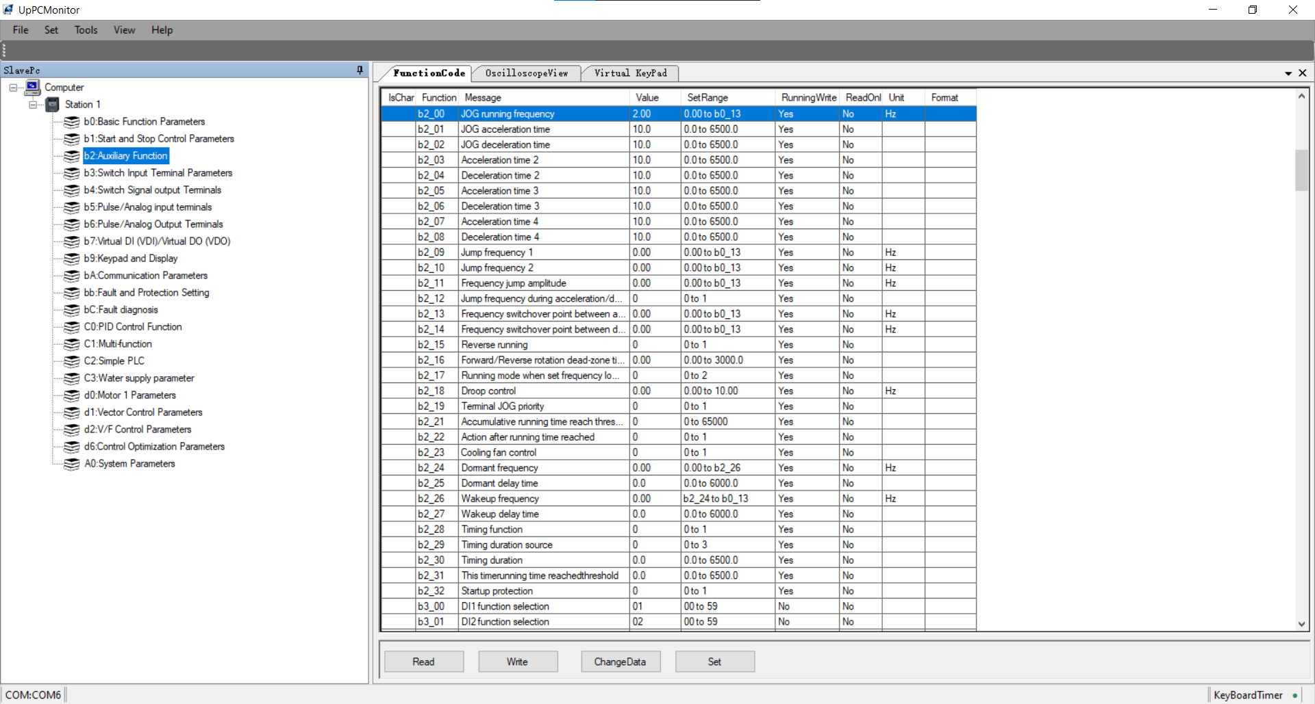

- OscilloscopeView Tab: The Oscilloscope view allows for recoding data for a specific parameter (select appropriate parameter from the “Monitor” dropdown list and adjust graph specifications using the settings below that). To start a recoding, select the “Start/Stop” button and stop it by selecting the same button. Data can also be cleared (“ClearData”) or saved (“SaveRec”).
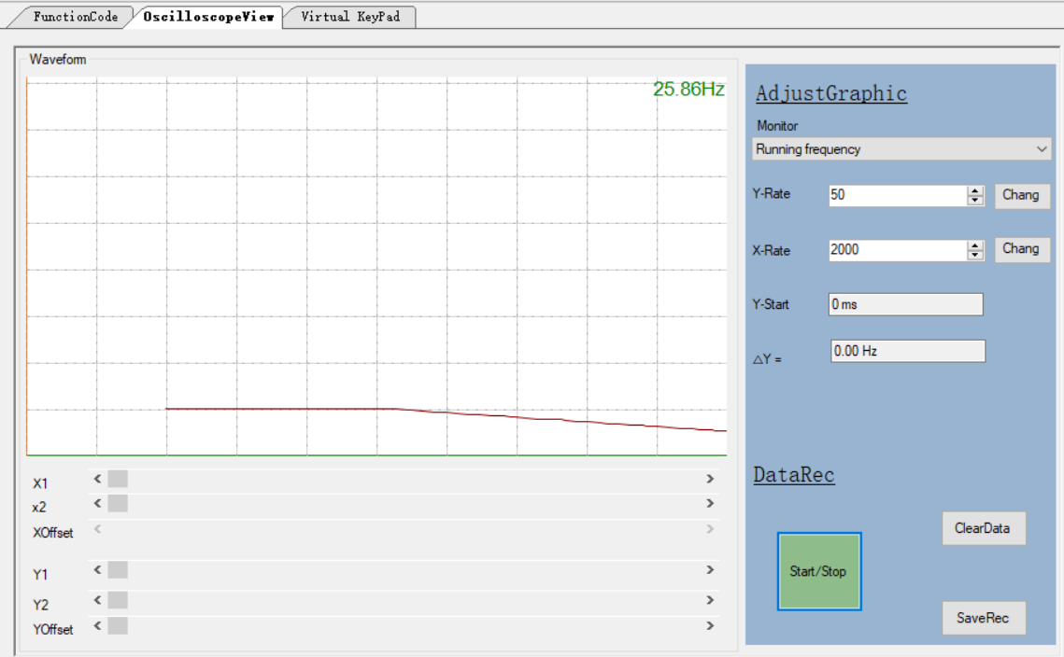
- VirtualKeypad Tab: The Virtual Keypad tab view allows for changing a few common parameters as listed on the left-hand side. It also allows for running and stopping the VSD using the function buttons on the right – selecting the specific monitoring parameter at the top right will ensure the actual running value for the specific monitoring parameter is displayed in the box below.
